# Department of Computing

**CS-344: Web Engineering**

**Class:** BESE-11AB

# Lab 07: PHP Basics

**Date: 27.10.22**

**Tanzeel Ur Rehman**

**345510**

**BESE 11-A**

# Instructor: Dr. Qaiser Riaz

# 

# Lab 07: PHP Basics

### Introduction:

PHP is a widely used server side scripting language for web development. During lectures, students have learned the syntax and basic concepts of PHP. Students have also learned basic PHP concepts of functions, control structures, conditional statements, arrays etc. Students will practically get in-depth practical knowledge of the basic PHP concepts in this lab.

### Lab Objectives:

The objective of this lab is helping students to familiarize themselves with the usage of PHP to control dynamic and server side behavior of a web site. Students will develop small PHP applications according to the given scenarios. The knowledge students have gained in the lectures will help them to understand syntax of PHP.

### Tools:

Notepad, DreamWeaver, browser.

### Helping Material:

Lecture slides.

W3Schools: <https://www.w3schools.com/php/>

PHP: <http://www.php.net>

### Lab Task

### Task 1

Note: In the supporting material compressed file (see ‘lab-07-supporting-material.zip’), a skeleton file is given which includes basic skeleton (‘task-1-skeleton.php’) for this task.

Write a PHP script to calculate and display average temperature, seven lowest and highest temperatures as shown in figure below. The temperatures array is already created and initialized in the skeleton script. (hint: php sort() function can be used to sort an array)

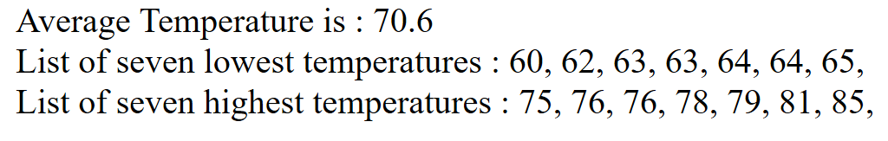

### Task 2

Note: In the supporting material compressed file (see ‘lab-07-supporting-material.zip’), a skeleton file is given which includes basic skeleton (‘task-2-skeleton.php’) for this task.

Write a PHP script that creates the following table using for loops

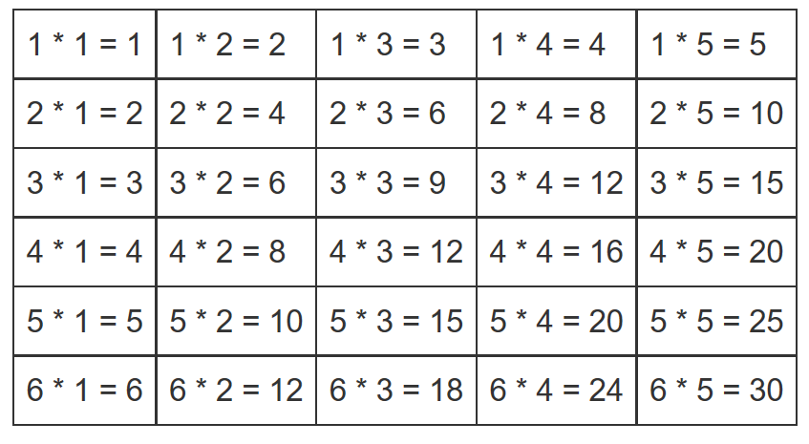

### Task 3

Note: In the supporting material compressed file (see ‘lab-07-supporting-material.zip’), a skeleton file is given which includes basic skeleton (‘task-3-skeleton.php’) for this task.

Write a PHP script using nested for loop that creates a chess board as shown below. (Hint: the chess board is an 8x8 table. Use ‘bgcolor’ property of each cell to make it black or white).



**Note: Upload complete solutions (css, html, js) for each task in in a single zip file along with adding jQuery and screenshots of your solutions in this word file.**

|  |
| --- |
| Solution |
| Task 1:  </head>   <body>     <?php      $month_temp = "78, 60, 62, 68, 71, 68, 73, 85, 66, 64, 76, 63, 81, 76, 73,            68, 72, 73, 75, 65, 74, 63, 67, 65, 64, 68, 73, 75, 79, 73";      //Converting the string to array.      $temp_array = explode(',', $month_temp);      //For Average Tempreture      function average_temp($array)      {        $sum = 0;        for ($i = 0; $i < sizeof($array); $i++) {          $sum += $array[$i];        }        echo "Average Tempreture is: " . ($sum / (sizeof($array))) . "<hr/>";      }      //For 7th lowest temperature.      function lowest_temp($array)      {        sort($array);        echo "List of seven lowest temperatures: ";        for ($i = 0; $i <= 6 && $i <= sizeof($array); $i++) {          echo $array[$i];          echo " ";        }        echo "<hr/>";      }      //For 7th highest temperature.      function highest_temp($array)      {        sort($array);        echo "List of seven hightest temperatures: ";        for ($i = sizeof($array) - 1; $i > sizeof($array) - 8 && $i >= 0; $i--) {          echo $array[$i];          echo " ";        }        echo "<hr/>";      }      //function Calls      average_temp($temp_array);      lowest_temp($temp_array);      highest_temp($temp_array);      ?>   </body>   </html>  Task 1 screenshot:  Graphical user interface, text, application, email  Description automatically generated  Task 2:  <!DOCTYPE html>  <html>  <head>      <title>Task-2</title>      <meta http-equiv="Content-Type" content="text/html; charset=UTF-8">  </head>  <style>      td {          height: 50px;      }  </style>  <body>      <table width=50% border=2px align="center">          <?php          //Outer loop for printing rows          for ($i = 1; $i <= 6; $i++) {          ?>              <tr align="center">                  <?php                  //Innner loop for printing columns                  for ($j = 1; $j <= 5; $j++) {                  ?>                      <td><?php echo "" . $i . " * " . $j . " = " . $j * $i . ""; ?></td>                  <?php                  }                  ?>              </tr>          <?php          }          ?>      </table>  </body>  </html>  Task 2 screenshot:    Task 3:  <!DOCTYPE html>  <html>  <head>    <title>Task-3</title>    <meta http-equiv="Content-Type" content="text/html; charset=UTF-8">    <style>      .black {        background-color: black;        width: 60px;        height: 60px;        float: left;        margin: 0;      }      .white {        background-color: white;        width: 60px;        height: 60px;        float: left;        margin: 0;      }      .clear {        clear: both;      }      .parent {        margin: auto;        width: fit-content;        border: 1px solid black;      }      h3 {        text-align: center;      }    </style>  </head>  <body>    <h3>Chess Board - PHP Nested Loops</h3>    <!-- cell 270px wide (8 columns x 60px) -->    <div class="parent">      <?php      for ($i = 0; $i <= 7; $i++) {        for ($j = 0; $j <= 7; $j++) {          if ((($i + $j) % 2) == 0) {      ?>            <div class="black">&nbsp;</div>          <?php          } else {          ?>            <div class="white">&nbsp;</div>        <?php          }        }        ?>        <div class="clear"></div>      <?php      }      ?>    </div>    </table>  </body>  </html>  Task 3 screenshot: |

### Deliverables

Compile a single word document by filling in the solution part and submit this Word file with code files on LMS. You must include your name, ID, and class on first page. The lab grading policy is as follows: The lab is graded between 0 to 10 marks. For some of the labs, students have to present their solutions in a viva session. In case of any problems with submissions on LMS, you should contact your lab engineer Ms. Ayesha Asif.